OSL WEEK 4

Q1)

#include <sys/types.h>

#include <sys/stat.h>

#include <unistd.h>

#include <stdio.h>

#include <stdlib.h>

void help() { printf("USAGE: inode [name_of_file]\n");

}

int main(int argc, char * argv[]) { if ( argc != 2 ) { help(); exit(EXIT_FAILURE);

}

struct stat curr_stat;

int r_val = lstat( argv[1], &curr_stat ); if ( r_val < 0 ) { perror("lstat"); exit(EXIT_FAILURE);

}

printf("Inode number: %ld\n", curr_stat.st_ino);

}

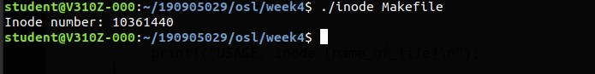

Q2)

#include <sys/types.h>

#include <sys/stat.h>

#include <unistd.h>

#include <stdio.h>

#include <stdlib.h>

#include <time.h>

#include <pwd.h> #include <grp.h>

void help() { printf("USAGE: stat [name_of_file]\n");

}

void pp(int r_val, char * str) { if ( r_val == 0 ) { printf("-");

} else { printf("%s", str);

}

}

void print_filetype(mode_t m) { if ( S_ISREG(m) ) { printf("Regular file");

} else if ( S_ISDIR(m) ) { printf("Directory");

} else if ( S_ISCHR(m) ) { printf("Character device");

} else if ( S_ISBLK(m) ) { printf("Block device");

} else if ( S_ISFIFO(m) ) { printf("Named pipe");

} else if ( S_ISLNK(m) ) { printf("Symbolic link");

} else if ( S_ISSOCK(m) ) { printf("Socket");

}

}

int main(int argc, char * argv[]) { if ( argc != 2 ) { help(); exit(EXIT_FAILURE);

}

struct stat curr_stat; struct passwd * file_usr = NULL; struct group * file_grp = NULL; int r_val = lstat( argv[1], &curr_stat );

if ( r_val < 0 ) { perror("lstat"); exit(EXIT_FAILURE);

}

mode_t m = curr_stat.st_mode;

printf("Inode number: %ld\n", curr_stat.st_ino); printf("Device id: %ld\n", curr_stat.st_dev); printf("Mode: %d\n", m); printf("File permissions: "); pp( m & S_IRUSR, "r" ); pp( m & S_IWUSR, "w" ); pp( m & S_IXUSR, "x" ); pp( m & S_IRGRP, "r" ); pp( m & S_IWGRP, "w" ); pp( m & S_IXGRP, "x" ); pp( m & S_IROTH, "r" ); pp( m & S_IWOTH, "w" ); pp( m & S_IXOTH, "x" ); printf("\n"); printf("File type: "); print_filetype(m); printf("\n");

file_usr = getpwuid(curr_stat.st_uid);

if ( file_usr == NULL ) { perror("getpwuid"); exit(EXIT_FAILURE);

}

file_grp = getgrgid(curr_stat.st_gid); if ( file_grp == NULL ) { perror("getgrgid"); exit(EXIT_FAILURE);

}

printf("UID: %d(%s)\n", curr_stat.st_uid, file_usr->pw_name); printf("GID: %d(%s)\n", curr_stat.st_gid, file_grp->gr_name); printf("Size: %ld bytes\n", curr_stat.st_size); printf("Block size: %ld\n", curr_stat.st_blksize); printf("No of blocks used: %ld\n", curr_stat.st_blocks); printf("Last access time: %s", ctime(&curr_stat.st_atime)); printf("Last modified time: %s", ctime(&curr_stat.st_mtime));

printf("Last status change time: %s", ctime(&curr_stat.st_ctime)); free(file_usr); free(file_grp);

}

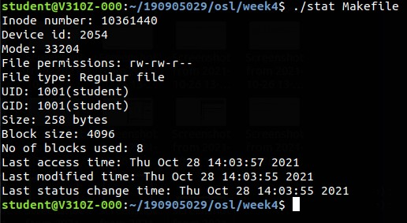

Q3)

#include <stdio.h>

#include <stdlib.h>

#include <limits.h> #include <unistd.h>

void help() { printf("USAGE: hlink [name_of_file]

[name_of_destination_file]\n");

}

int main(int argc, char * argv[]) { if ( argc != 3 ) { help();

exit(EXIT_FAILURE);

}

int r_val = link(argv[1], argv[2]);

if ( r_val < 0 ) { perror("link"); exit(EXIT_FAILURE);

} char * path = realpath(argv[2], NULL);

if ( path == NULL ) { perror("realpath"); exit(EXIT_FAILURE);

} printf("Path to hard link: %s\nEnter to exit: ", path); getc(stdin);

r_val = unlink(argv[2]); if ( r_val < 0 ) { perror("unlink"); exit(EXIT_FAILURE);

}

free(path);

}

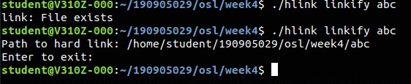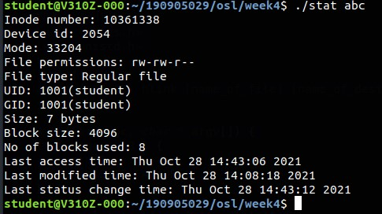

Q4)

#include <stdio.h>

#include <stdlib.h>

#include <limits.h> #include <unistd.h>

void help() { printf("USAGE: symlink [name_of_file]

[name_of_destination_file]\n");

}

int main(int argc, char * argv[]) { if ( argc != 3 ) { help();

exit(EXIT_FAILURE);

}

int r_val = symlink(argv[1], argv[2]);

if ( r_val < 0 ) { perror("link"); exit(EXIT_FAILURE);

} char * path = realpath(argv[2], NULL);

if ( path == NULL ) { perror("realpath"); exit(EXIT_FAILURE);

} printf("Path to hard link: %s\nEnter to exit: ", path); getc(stdin);

r_val = unlink(argv[2]); if ( r_val < 0 ) { perror("unlink"); exit(EXIT_FAILURE);

}

free(path);

}

